Chrono: Planning and Design Document for a new Time-Tracking Mobile App

Jishen Harilal ST10083511 | Evan Teague ST10083451

*DOCUMENT IN PROGRESS, Incomplete Areas marked in red

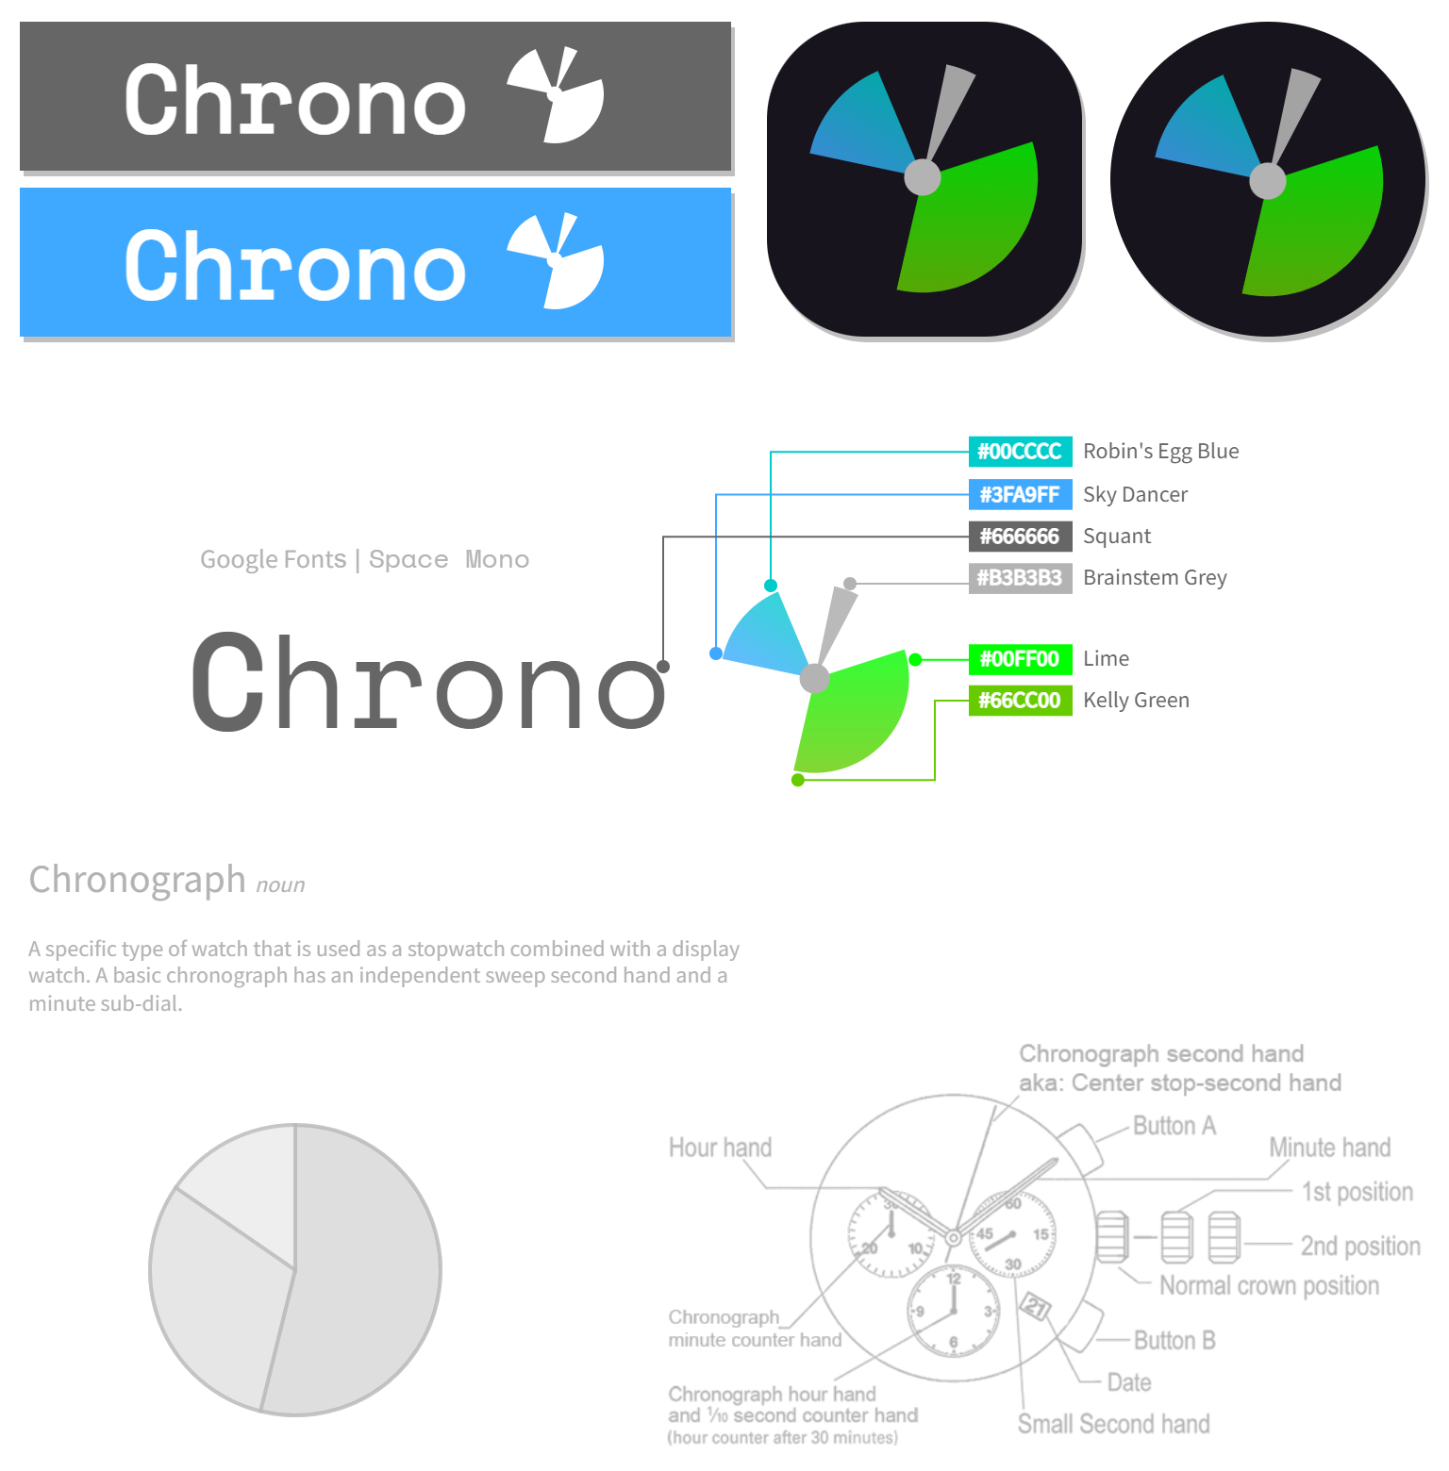

**Introduction**

This 'planning and design' document outlines the key features and functionalities of the application, along with its user interface, user experience, and technical implementation details and serves as a guide for the development team, providing a clear vision of the app's purpose, functionality, and user interactions.

**Overview of Chrono**

Chrono is an Android mobile app designed to help users track and manage their time spent on client projects. It provides a user-friendly interface for creating and managing timesheet entries, setting goals, and visualizing time usage through various charts and graphs. The app aims to improve productivity, accountability, and efficiency in managing work hours for different projects or categories.

**Key Features:**

* User Authentication
* Timesheet Entry Creation
* Goal Setting
* Gamification in the form of ‘Daily Goal Streaks’
* Timesheet Entry Management
* Time Usage Visualization
* Online Database

**Target Users:**

* Professionals
* Freelancers
* Individuals
* Teams
* Small businesses in various industries such as consulting, design, development, marketing etc.

**Functional Requirements**

|  |
| --- |
| **1. The app must allow users to sign in with a username and password.**  We'll utilize Firebase Authentication to authenticate users. This will allow for user-specific data so each user will only be able to see their timesheet entries and will only receive notifications for their tasks. |
| **2. The ability for the user to make categories for the timesheet entries is required.**  The categories will allow to user to organize their timesheet entries so that they are easier to find whenever the user wants to acquire them. |
| **3. A timesheet entry must be created by the user and include at least the date, the start and end timings, the description, and the category.**  These timesheet entries will allow users to set a certain amount of time aside on a certain day to complete a task. This will help the user in terms of time management and time-tracking so they can see how they spent their time at a specific time of day. |
| **4. The user must be able to optionally add a photo to each timesheet entry.**  The photo can be of what the user completed in the duration of the time entry, and this will add to the user experience as the photos may make using the app more enjoyable and allows for more personalisation for each timesheet entry. |
| **5. The user must be able to specify both a minimum and maximum daily objective for hours worked.**  This allows the user to assign a certain amount of time for each timesheet entry, so they know they only have that amount of time to complete or do whatever they need to over that duration. |
| **6. The user must be able to see a list of all timesheet entries made over a period they can choose.**  The user must be able to retrieve any photos that were saved for entries from this list. This adds to the usability of the application, so the user does have to scroll through many entries to find what they are looking for. |
| **7. The total number of hours spent on each category throughout a user-selectable time-period must be visible to the user.**  This data will indicate to the user how much time they are spending on each category during a certain time-period. |
| **8. The user must be able to examine a graph that displays the total number of hours worked each day over a timeframe they can choose.**  The graph also needs to show the minimum and maximum objectives. The graph will give a visual representation of the total hours worked each day over a user-selectable period. |
| **9. The app must show the user's progress over the past month in terms of meeting their minimum and maximum hour targets in a visually appealing manner.**  The user will be able to visualize their progress over any selected days of the month. |
| **10. An online database must be used to store the data.**  The user’s data must be persistent as well as allow the user to log in on a separate device to receive their data. |
| **11. The user must receive reminders and notifications for when a task is nearing the end time and for when a task is overdue.**  This feature is beneficial as it will assist the user in completing their task in the required time frame and will also increase user engagement (crustlab, 2022). |
| **12. The user should be allowed to export a report of their timesheet data to a pdf.**  The user should be able to export a list of their timesheet entries over a specific time-period to a pdf file, so that they can send the data to another person via a pdf file (pdf.wondershare, 2023). |
| **13. The user should be allowed to change the application to dark mode.**  This will add to user experience as it will reduce eye strain for the user (forms.app, 2022). |
| **14. Gamification should be added to the application in the form of daily streaks, rewards, and `challenges (trackabi, N/d).**   * **Daily Streaks:** Encourage users to log their time daily with a daily streak system. For example, if a user logs their time for three consecutive days, they receive points or a badge. If they continue to log their time every day, the streak increases (trackabi, N/d). * **Rewards:** Offer rewards to users who consistently log their time. These could be virtual rewards like badges or points that can be used to unlock additional features or perks within the app (trackabi, N/d). * **Challenges:** Create challenges that encourage users to log their time in creative ways. For example, users could be challenged to log their time while standing up or while listening to a particular type of music. Users could earn points or badges for completing these challenges (trackabi, N/d). |

**User Interface Design Mock-ups**

**Login and Registration UI**

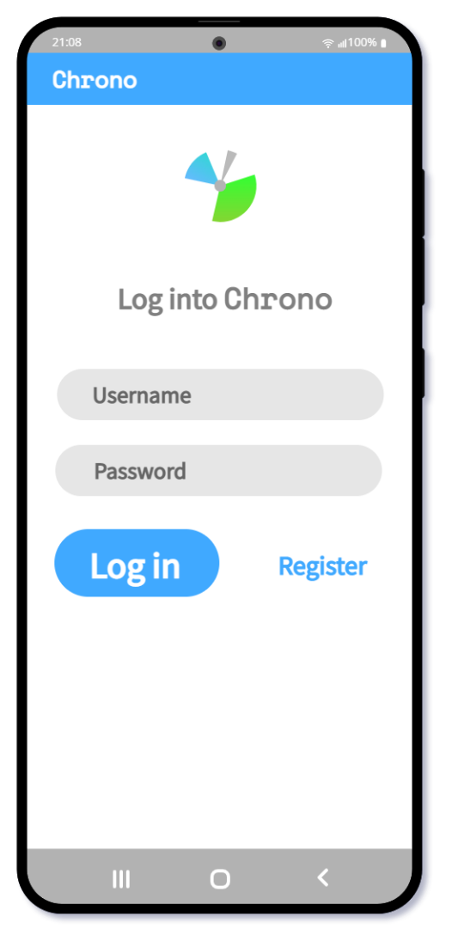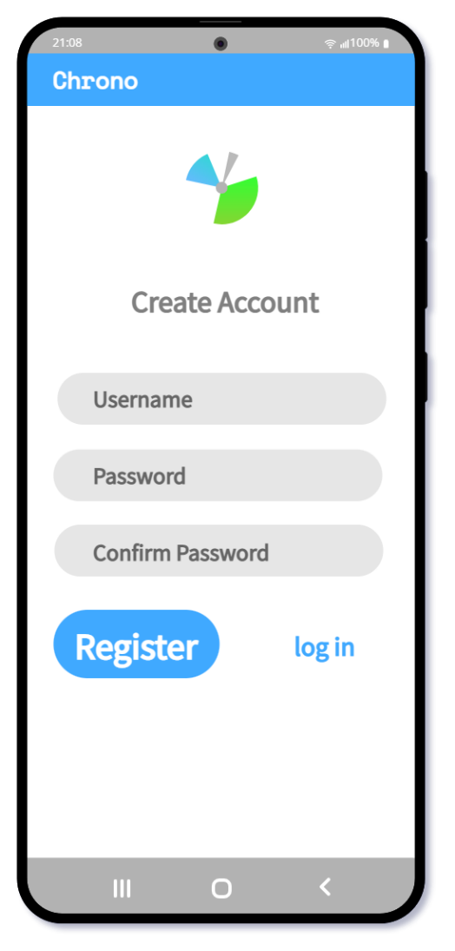

**Description:**

The login and registration UI are similar in appearance and try to achieve a clean, modern, and friendly aesthetic.

**Purpose:**

* On startup, the user will be greeted with the login screen, and if they have signed in recently, will be automatically logged in.
* The login screen will allow the user to log in to an account that they have previously created.
* If the user does not have a Chrono account, they can register a new account by clicking on the ‘Register’ TextView.
* The register screen will allow a user to create a new account, all they need to provide is a username and password, they will also be required to confirm the password.

**Your Activity UI**

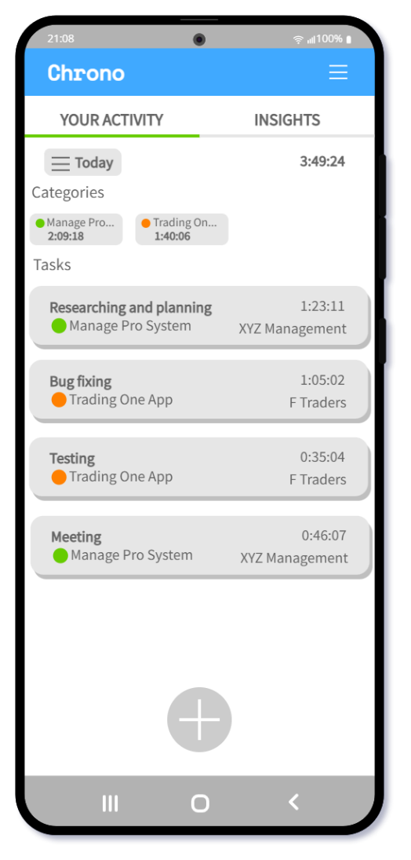

**Description:**

The ‘Your Activity’ section is mainly inspired by that of the Toggl Track mobile app. This UI is designed to be as minimal as possible, modern and user friendly, avoiding intimidating charts or diagrams.

**Purpose:**

* Once logged in, the user will be taken to the ‘Your Activity’ UI, where they can view their timesheet entries.
* The user can also switch between ‘Your Activity’ and ‘Insights’.
* The user will be able to view entries from different selectable time periods, e.g. Today, This Week, Last Week, Past Month, This Year, All Time, Advanced. They will be able to view entries made between specific dates using the ‘Advanced’ option.
* Categories of the listed entries will also be listed, together with the total time spent on that category for the given time-period selection.
* The task list contains entry items that include the description, the time spent on that task, the category, and the name of the client. The list will utilise a recycler view.
* When an entry is selected, the user will be able to access more information such as the date, start and end times of the task, and its attached image.
* A new task can be created by clicking the ‘Add’ button at the bottom of the screen.

**New Entry UI**

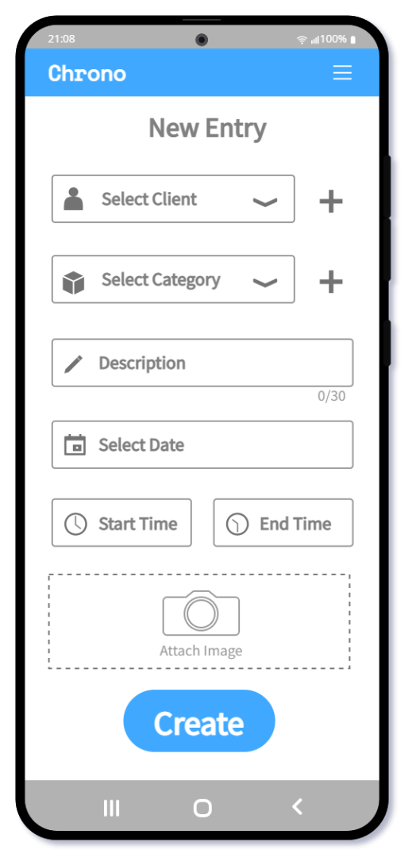

**Description:**

The ‘New Entry’ UI enables the user to create a new entry, add categories and clients, and attach images to their entry.

**Purpose:**

* When the user clicks the ‘Add’ button on the ‘Your Activity’ screen, they will be taken to this screen to create a new entry.
* The user can specify a description of the task, start and end times, date, provide and image and categorize the task.
* When the user clicks the ‘Create’ button the entry will be added to the database and can be accessed by the user from the ‘Your Activity’ list.

**View Entry UI**

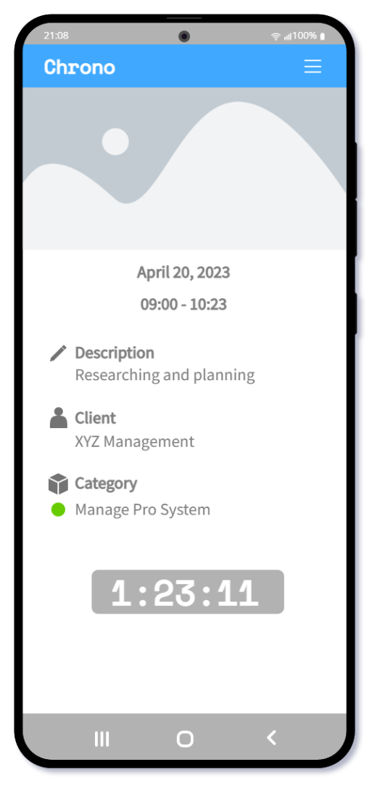

**Description:**

The ‘View Entry’ UI shows more detailed information about a selected entry.

**Purpose:**

* The ‘View Entry’ screen appears when an entry is selected from the entry list.
* The user can view more detailed information that they have recorded, such as the attached image at the top of the screen, as well as the time spent on that specific activity.

**Insights UI**

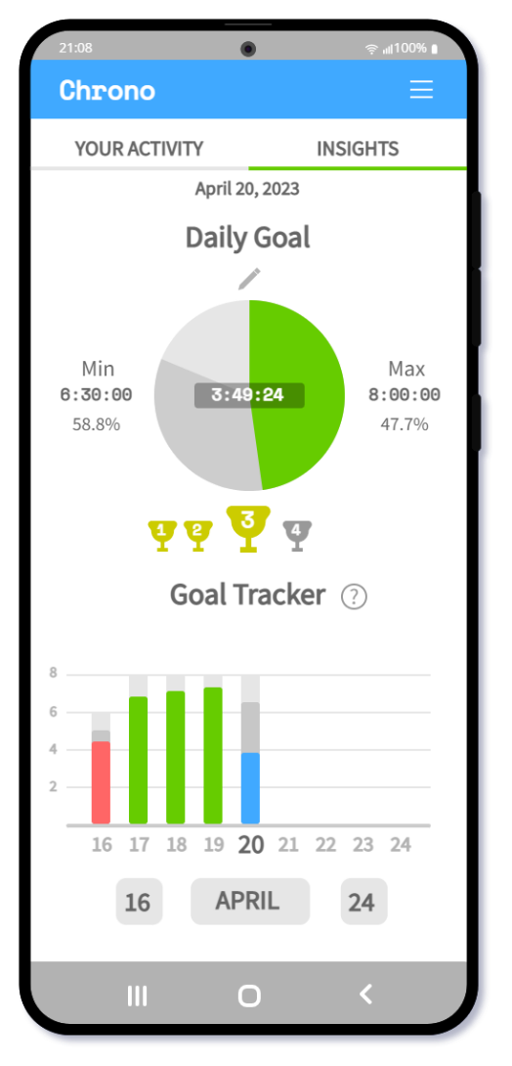

**Description:**

The ‘Insights’ UI shows useful information regarding user goals and progress, as well as how well they are sticking to their goals.

**Purpose:**

The user can :

* set their max and min daily goal track their progress with the daily goal pie chart.
* see how many days in a row they have hit their goal.
* view information on how well they are sticking to their goals over a user-defined time-period, using the goal tracker’s stacked bar graph.

**User Interface Navigation Diagram**

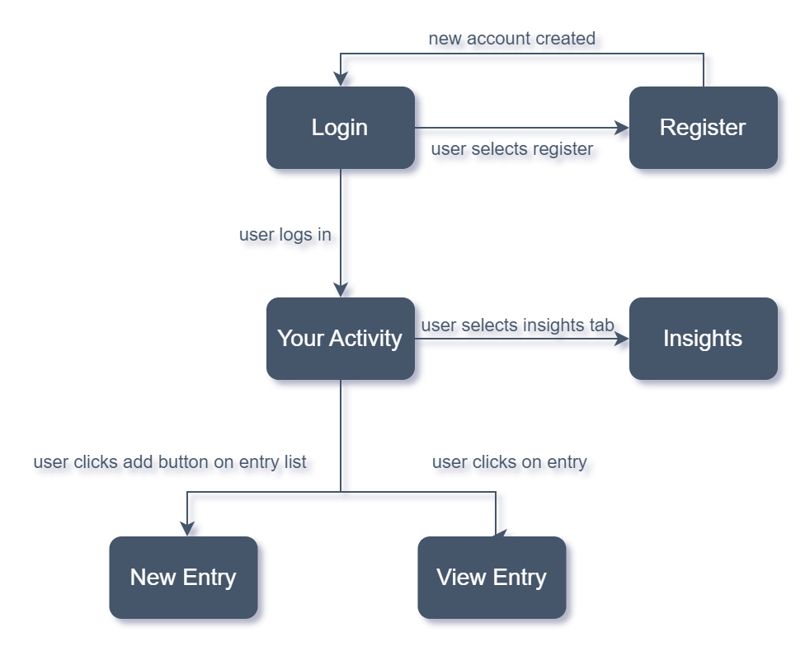

**Project Plan: Gantt Chart**

**GANTT CHART**

**Conclusion**

In conclusion, our planning and design document for the Chrono time-tracking app has outlined the key features and functionality based on careful research and analysis of existing time-tracking apps such as Toggl Track, TimeCamp, and Clockify. We aim to create a comprehensive and user-friendly time-tracking solution that meets the needs of our target users.

**Bibliography**

* crustlab. 2022. Benefits of push notifications, 2 November 2022.[Online]. Available at: <https://crustlab.com/blog/benefits-of-push-notifications/> [Accessed 22 April 2023]
* forms.app. 2022. The benefits of dark mode: Why you should dim the lights, 16 September 2022.[Online]. Available at: <https://forms.app/en/blog/benefits-of-dark-mode> [Accessed 22 April 2023]
* pdf.wondershare. 2023. Applications and Advantages of PDF in Mobile Internet, 13 April 2023.[Online]. Available at: <https://pdf.wondershare.com/pdf-knowledge/use-and-benefits-of-pdf-in-mobile-internet.html> [Accessed 22 April 2023]
* trackabi. N/d. Gamification Of Time Tracking: Higher Motivation & Increased Productivity, N/d.[Online]. Available at: <https://trackabi.com/blog/gamification-of-time-tracking> [Accessed 22 April 2023]